Python Try Except // Python Functions

The try block lets you test a block of code for errors.

The except block lets you handle the error.

The else block lets you execute code when there is no error.

The finally block lets you execute code, regardless of the result of the try- and except blocks.

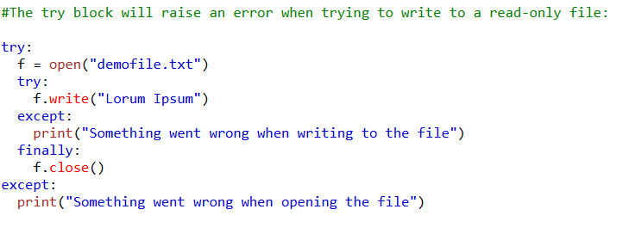

Raise an exception

As a Python developer you can choose to throw an exception if a condition occurs.

To throw (or raise) an exception, use the raise keyword.

